**Aim:**

To demonstrate Infrastructure as a Service (IaaS) by establishing a remote connection to a Virtual Machine deployed on Microsoft Azure, launching the VM image, and running it from a local desktop.

**Procedure:**

1. Login to Azure Portal

* Open https://portal.azure.com.
* Sign in using your Azure account credentials.

2. Navigate to the Deployed VM

* Go to Resource Groups → select the created group (IaaS-Demo-RG).
* Select the Virtual Machine (IaaS-Demo-VM).

3. Get Public IP & Connection Details

* Under VM Overview, copy the Public IP Address of the VM.
* Ensure Inbound Port Rules are enabled (SSH for Linux / RDP for Windows).

4. Connect to the VM

* For Windows VM:
  + Click Connect → RDP.
  + Download the .rdp file.
  + Open the file on your desktop and log in using the username and password set during VM creation.

5. Launch and Run the VM

* Once connected:
  + For Windows VM → The Remote Desktop opens and you can use the VM like a normal Windows machine.
  + For Linux VM → The SSH terminal provides full Linux shell access to run commands.

6. Verification

* Run basic commands:
  + Windows: Open Command Prompt → ipconfig

**Output:**

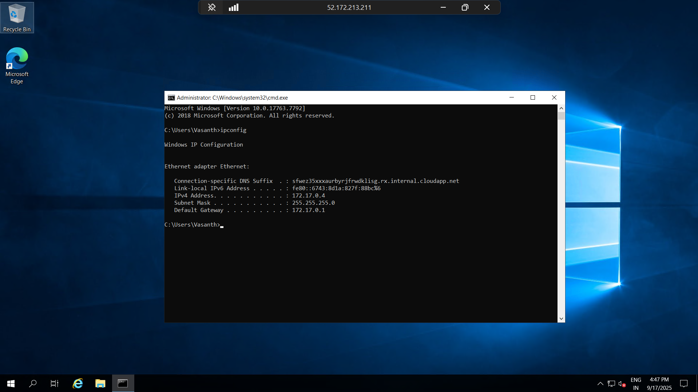

**Result:**

Infrastructure as a Service (IaaS) was successfully demonstrated by establishing a remote connection from the desktop to the Azure Virtual Machine. The VM image was launched and basic commands were executed, proving that the VM is fully functional and accessible through Azure IaaS.